Lab 8 Screenshots

Dillon Britt

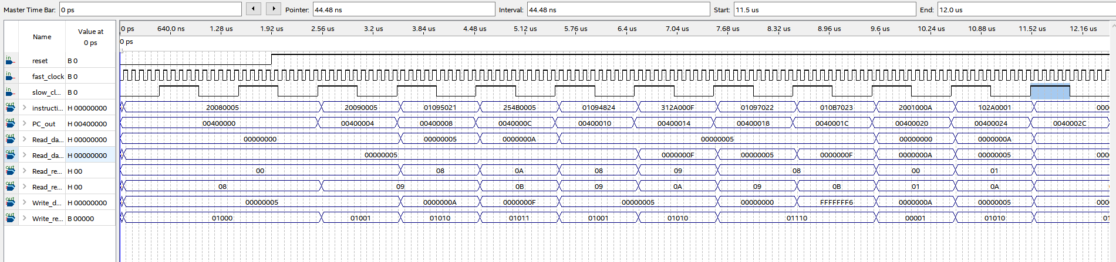

ADDI ADDI ADDU ADDIU AND ANDI SUB SUBU ADDI BEQ ADD

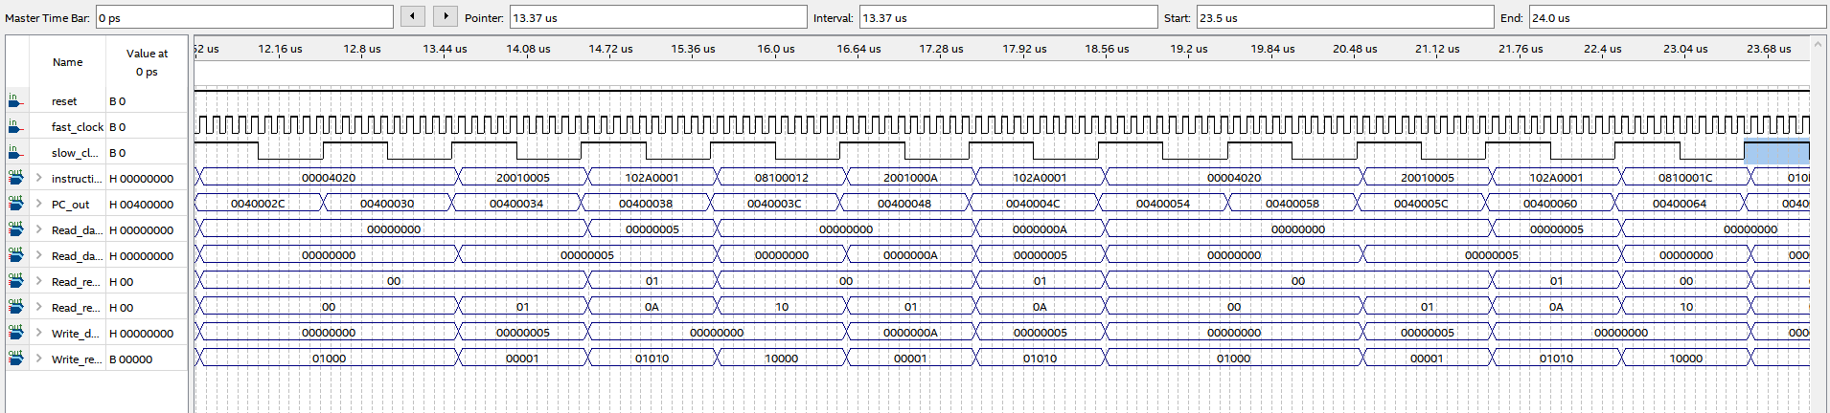

ADD ADD ADDI BEQ J ADDI BEQ ADD ADD ADDI BEQ J

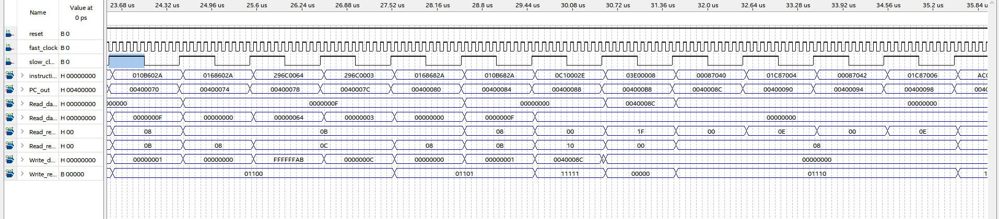

SLT SLT SLTI SLTI SLT SLT JAL JR SLL SLLV SRL SRLV

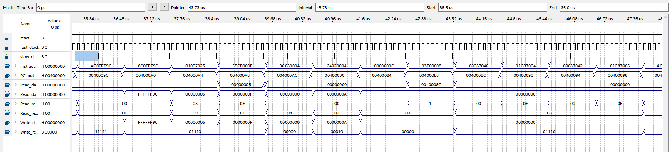

SW LW OR ORI LUI ADDIU SYSCALL